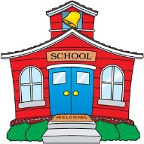Robbins School Activity Schedule

August 2023

Wed 16 First Day of School @ 8:20 a.m.

Wed 16 Minimum Day Dismissal at 1:00 p.m. Lunch will be served

Thurs 17 Back to School Night @ 6:00 p.m.

Fri 2 Health and Wellness Day at Robbins School from 10:00 a.m.- 2:00 p.m.

Wed 23 Minimum Day Dismissal at 1:00 p.m. Lunch will be served

Wed 30 Minimum Day Dismissal at 1:00 p.m. Lunch will be served

Lista de Actividades de la Escuela Robbins 

Agosto 2023

Mier 16 Primer día de clases 8:20 a.m.

Mier 16 Día mínimo salida a las 1:00 p.m. se servirá lonche

Juev 17 Noche de regreso a clases @ 6:00 p.m.

Vie 2 Health and Wellness Day at Robbins School from 10:00 a.m.- 2:00 p.m.

Mier 23 Día mínimo salida a las 1:00 p.m. se servirá lonche

Mier 30 Día mínimo salida a las 1:00 p.m. se servirá lonche